Curriculum Vitae

Alok Singh  Add- Vill-marahariya,post-saunsarapur,  Distt-kannauj(U.P)-209733  Mob: 7309475883,7985869339  Email – aloks1740@gmail.com | 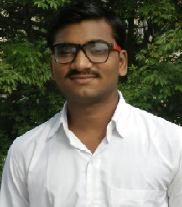

Career Objective:-
Willing to work in a stable and conducive environment to keep up with the cutting edge of technologies, updating my skill set and ensuring self-growth along with growth and development of the organization.
Educational Qualification:-
- B.C.A. from Kanpur university campus (U.I.E.T Kanpur) with 60% in 2017.
- Intermediate from UP Board Allahabad with 81.80% in 2014.
- High school from UP Board Allahabad with 81.33% in 2012.
Technical Skills:-
- PHPprogramming.
- C and C++ programming.
- Java core and advance programming
- Dot Net Technology
- HTML,CSS,Java Script programming languages
- Data Base Management System (MySql,Orracle).

Personal Skills:-
- Good Communication Skills.
- Having the ability to adjust myself with environment.
- Ability to work in a team
- Incredible potential, hardworking nature, and highly innovative
- Desire to learn more and more
- Ability to deliver the desired results within scheduled time

Work & Experience:-
These are the following website and software which are developed by me.
- www.relevancefresh.com
- www.medicmanual.com
- www.duniyapazaro.com/ecom
- www.hyadesinfra.org
- www.relevancegroup.in
- Offline Exam System (JAVA swing technology with mysql database)
- Mood Prediction Music System(Jsp technology with mysqldatabse)

Hobbies:-
- Singing.
- visiting on internet

Personal Details:-
- Date of Birth 02/08/1998
- Father’s Name Mr.Arunkumar singh
- Marital Status Unmarried
- Gender Male
- Languages Known Hindi, English both can read,write&speak
- Nationality Indian

Declaration:-
I hereby confirm that the above mentioned information is correct up to my knowledge and I bear responsibility for the correctness of the above mentioned particulars.

Place…….. (Alok singh)
Date……….

