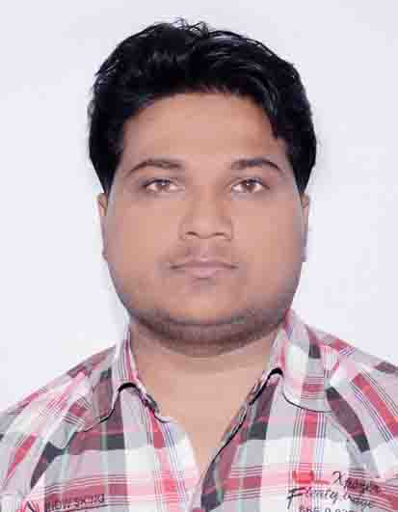

## ***Curriculum vItAe***

**Vipin Singh**

**Add-Village- Gopal Ganj, Post-Kalyanpur**

**Dist- Fatehpur, U.P, pincode-(212664)**

**Mobile no- +91-8303616656**

**Email ID-** [**vipin.singh3657@gmail.com**](mailto:vipin.singh3657@gmail.com)

## **Career Objective**

Seeking an entry level position in a growth oriented organization in the field of Social Activities .

This will help me to utilize my strengths and skills towards the attainment of my objective.

## **AcademicS qualification**

|  |  |  |  |
| --- | --- | --- | --- |
| **Qualification** | **Board/University** | **Year Of Passing** | **% Of Mark’s** |
| Highschool | U.P.Board | 2008 | 58.88 |
| Intermediate | U.P.Board | 2010 | 62.22 |
| B.Sc. | C.S.J.M.University Kanpur | 2013 | 55.25 |
| MSW | Kalinga University | 2016 | 66.16 |

## **technical**

* CCC Certificate For Computer Knowledge.
* 1 year Computer Certificate.
* Certificate From Online Learning Platform **Skillsbuild**. A Partnership Betweem IBM And Skillsoft.

1. **Effective Team Communication**

**2. Making An Impact with Non-Verbal Communication**

**3. Using Active Listening in Workplace Solution**

**4. Professinal Skill in Collbaration**

**5. Creative Thinking, Problem Solving, Digital Workplace**

**6. Data And Analytics**

***BADGES ACCHIVED FROM SKILLSOFT:-***

 

## **WORK EXPERIENCE& Feature’s**

* 3 Years Work As A Block Motivator in Swachay Bharat Mission Gramin. Work with Community Led Total Sanitation(CLTS) And Solid Liquid And Waste Managemant (SLWM) A Programme of Panchayati Raj Department Fatehpur U.P.,
* Work with Data Collection,Survey,Investigation To Relative Mission. Manage & Co-Ordinate Team to work Better In Field.
* Expert In Team Management Coordination.Surveyar and Collect Data To Raletaed Field.
* Excellent communication, observation and listening skills And Ability to work efficiently to meet deadlines, and independently as well as in a team and Collection of secondary data & other related field work…
* Knowledge To Control Manpower & Work with team.
* Work in close coordination with the supervisors who will plan the day-to-day activities on the field.  
  • Update, maintain, and submit the data collected from the field on a daily basis. Ensuring quality & quantity targets for the surveys   
  • Maintain field observation notes and share their findings regularly with the research team.  
  • Ensuring the quality of data collected from the field and making revisits as and when required  
  • Identify, recruit participants (eg. Household, eligible person) and conduct interviews or other methods as per the study protocol.  
  • Coordinate with the team leader, program and facility staff to plan the data collection activities.  
  • Ensure timely reporting of activities and progress updates to the supervisor.  
  • Participate in training and data collection skill development with a research team.   
  • Debrief with participants and disseminate field findings with research team where relevant.

## **Computer & software knowledge**

* **Oprate Windows Xp/ 7.0/ 8.0/ 8.1/ 10 And ERP For Company Base Work.**
* M.S.Word, Excel, Powerpoint & Photoshop 7.0 .
* **Maiitain report in ms word, ms Excel,**
* **Data And Anyltics Software’s. And E-communication Plateform Like VC,Zoom & Cisco.**

## **Personal vitae**

**Father’s name -**Mr. Santosh Singh

**Date of birth - 10th Feb 1993**

**Gender -** Male

**Nationality -** Indian

**Language known -** Hindi (Fleuten)

English( Read.Write)

**Married status -** Single

## **declaration**

I hereby declare that all the information furnished above is true to the best of my knowledge and belief.

**Date: 18/06/2020** (Vipin Singh)

**Place: FATEHPUR**