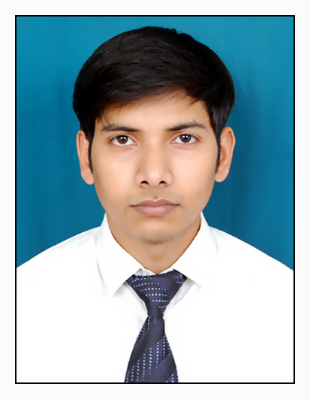
NAME: AKSHAY SINGH

Address: Ck62/77 Pratap niwas Kashipura Varanasi.
Mob: 8382804984
Email: singhakshay2911@gmail.com

OBJECTIVE:
To work in a company having an environment of constant learning with emphasis on quality thereby benefiting the organization and self .

EDUCATIONAL CREDENTIALS
MASTERS: PGDM, (Marketing/HR) Institute of Marketing and Management, New Delhi, 2012-2014

BACHELORS: B.B.A. School of Management sciences, Varanasi, 2011

XII: Dr. A.I. Memorial Sunbeam School, CBSE, Varanasi, 2008

X: Dr. A.I. Memorial Sunbeam School, CBSE, Varanasi, 2006

SUMMARY OF SKILLS:

- Market Research
- Team Leadership
- Ms Office

PROFESSIONAL EXPERIENCE

- Organisation Name : Bridgestone India Private Ltd.
Duration : December 1, 2014 to June 2, 2015
Designation : Management Trainee
Department : Sales and Marketing

PROJECTS UNDERTAKEN:

- Organisation Name: Bridgestone India Private Ltd
Duration: 1st July 2013 to 31st Aug 2013
Designation: Management Trainee
Description: Market Survey of Tyre Dealers, Tour & Travels Agent in Delhi.

Date of Birth: 04-08-1990
Hobbies: Listening music, interacting with People.
References:
Date:
Place: Signature:

