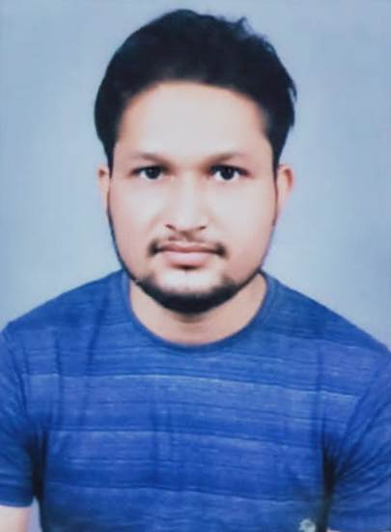    Prashant Singh  Add:- Jal Nigam Road, Balaganj, Lucknow.  Mob: 9936346032  Current Location: Lucknow  Email Id: 99363460p@gmail.com  ABOUT ME  - Im a writer, aged 28 years, Lucknow Uttar Pradesh. Born to Dinesh Singh and Kamla Singh on March 13, 1994.  SKILLS  - Story Writing.  - Video Editing.  - Poetry Write  Declaration  I hereby declare that the above information provided by me is true and fair to the best of my knowledge.  (Prashant Singh) | PRASHANT SINGH  EXPERIENCE  Trainee Video Editor  Swadesh News.  EDUCATION  (2018  2020)  Masters of Journalism & Mass Communication  M.C.R.P.V. (Bhopal)  (2015  2017)  Masters of Arts in Hindi  D.S.M.N.R. University, Lucknow  (2011 - 2014)  Bachelor of Arts  University of Lucknow, Lucknow  (2010-2011)  Intermediate  UP Board  (2007-2008)  High School  UP Board  ACTIVITIES  Participate in Nukkad Natak (Dowry), Seminars  Samaveshi Shiksha.  Parampara & Adhunikta

