RESUME
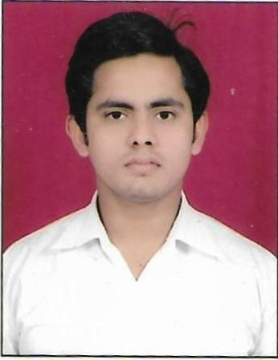
MOHD RIJWAN
Vill: Golwa Post:Sirsa Chauraha
Prayagraj ,Pin code- 221503
Contact No.- 6388015242
Email- mohdrijwan11036@gmail.com
OBJECTIVE
- Since I believe in giving my hundred percent to whatever I do, I Seek appropriate and professional atmosphere where I am motivated to take on challenging responsibilities, which help me grow steadily as a competitive professional and feel the better job satisfaction.

EDUCATIONAL QUALIFICATION

S.No. | Course | Board | Year of Passing | Division
1. | High School | UP BOARD. | 2014 | 1st
2. | Intermediate | UP BOARD | 2016 | 1st
3. | BCA | ALLAHABAD STATE UNIVERSITY | 2020 | 1st
COMPUTER SKILLS
- Frame Work : Wordpress
- Server Side Language : PHP
- Web Designing : HTML, CSS, CSS3, BOOTSTRAP,HTML5
- Scripting Language: Java Scrit, Jquery ,Es6
- SQL Language: MySQL, Oracle
PERSONAL DETAILS

Date of Birth : 10 Sep 1998
Fathers Name : Mr. Nisar Ahmad
Sex : Male
Marital Status : Unmarried
Nationality : Indian
Languages Known : Hindi & English
Hobbies & Interest : Reading Books, Watching Cricket and Interacting with people.

DECLARATION:
I hereby declare that the forgoing information is correct and complete to the best of my knowledge and belief.

Date:
Place: Prayagraj Mohd Rijwan

