CURRICULUM VITAE
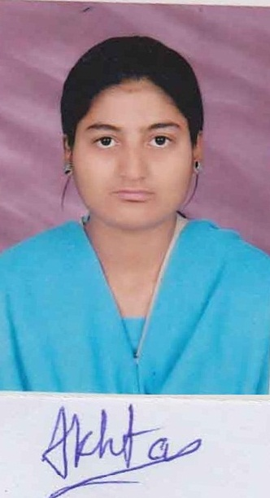

AKHTAR PARVEEN
Address: H.No. 255, Peeli Building, Email ID: akhujapbca@gmail.com
Near Chishtiya Mosque, Krishna Nagar, Mobile No.: 8109172486
Berkhera Pathani, Bhopal (M.P.)
Pin- 462022

CAREER OBJECTIVE

To become a successful professional in a highly competitive technological world where performance is rewarded with new challenging responsibilities and to serve a reputed growth oriented industry in the field of Design, Development and Maintenance.

ACADEMIC QUALIFICATION

- MCA(L.E.) from Makhanlal Chaturvedi University, MP Nagar, Bhopal (M.P.) in the year 2016
- BCA from Mastek Academy (Affiliated to MCNUJC) Saraswati Nagar, Jawahar Chowk, Bhopal (M.P.) in the year 2013
- Higher Secondary from Dr.Radhakrishnan Senior Secondary School (Affiliated to CBSE Board) in the year 2010
- High School from Dr.Radhakrishnan Senior Secondary School (Affiliated to CBSE Board) in the year 2008

WORKING EXPERIENCE

- Working as a PHP Web Developer in RS Vision Software Pvt Ltd, Bhopal from December 2016 to October 2018

TRAINING PROJECTS EXPERIENCE

- “Canteen Management System” Minor Project in C++.
- “Madhya Pradesh Historical Places Management System” Major Project in VB.NET (Front End) and MS-Access (Back End).
- “Online Car Rental System” Major Website in ASP.NET with C# (Front End) and MS Access (Back End).
- “College Event Portal” Major Web Application in PHP (Front-End) and MYSQL (Back End).

LATEST PROJECTS & EXPERIENCE

- Overall, I have 2 years of experience in the field of software and website development. The websites developed are certainly static and dynamic based websites. I have created more than 20+ websites which is related to health and wealth, newsletter, hygiene products, garage equipments, etc.
- Latest Projects include rsvisionsoftware.com, emediawebsolution.com, perfectopedia.com, ficgarageequipments.com, benzhygienesolutions.com, bankersacademyryp.online and so on. The payment gateways integrated on dynamic websites include PayPal.

TRAINING PROGRAMMES

- Participated in workshop “ANDROID TECHNOLOGY” conducted by CRISP, Bhopal as on 22 Feb 2014
- Done “.NET TECHNOLOGY” Training Programme from CRISP, Bhopal
- Done Major Project Training in PHP from GenxSoft Technologies Pvt. Ltd., Bhopal

TECHNICAL KNOWLEDGE

Operating System : Windows XP, Windows 7, Windows 8, LINUX
Coding Languages : C, C++, Java (Core), VB.NET, C#.NET, ASP.NET, PHP (Core PHP, WordPress)
Web Technologies : HTML, CSS, JavaScript (AngularJS, JQuery)
Web Server : Wamp, Xamp
Web GUI Design : Adobe Dreamweaver, Photoshop, Lunapic
Web Hosting Control Panel : Control Panel
Database : MS-Access, Oracle, SQL Server, MySQL.
Desktop FTP Client : FileZila.
Office Package : MS-Office 2003, MS-Office 2007, MS-Office 2010

PERSONAL DETAILS

Father’s Name : - Shri. Iqtadarul Haque
Date of Birth : - 18th June 1991
Gender : - Female
Marital Status : - Unmarried
Languages Known : - Fluent in English and Hindi
Nationality : - Indian
Hobbies : - 1. Playing Outdoor games
2. Listening Songs
3. Doing Mimicry

DECLARATION
I hereby declare that all information in this resume is true.

Date: -
Place: - Bhopal Akhtar Parveen

